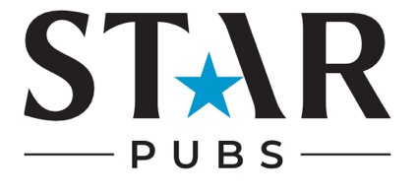

Summer Checklist

Appearance
- Have you updated your pub’s cover image/banner to a summer-themed picture?
- Have you created high-quality summer-themed content to post across your social media channels?

Bio Content:
- How are you going to add information about your summer events and offers to your bio?
- Have you included a call to action? e.g. Book your summer party today
- Have you included links to summer bookings/menus/events?

Competitions:
- Are you going to launch a summer competition?
- Have you decided on a worthy prize? E.g. A summer tasting menu, BBQ meal or access to a summer event at your pub?
- Are you going to promote the competition across all social media channels to boost awareness and engagement?

Ads
- What are you trying to achieve with your summer ad? E.g. awareness, engagement, bookings.
- Have you scheduled ads to run in the peak lead up to key summer weekends e.g. May and August bank holidays?
- Have you created summer-themed ads to promote your pub’s events, menus, bookings and drinks specials?
- Have you linked ads to your pub’s summer bookings landing page?

Influencers
- Have you identified local influencers who align with your pub’s values?
- Have you reached out to influencers about collaborating on summer content?
- Have you set up arrangements for influencers to visit your pub to film/capture content?
- Are you going to reshare influencer content on the pub’s social media? How is this going to be done? E.g. repost to stories, repost to feed, collaborative post

Key dates for your pub’s diary:
May Bank Holidays
May Half Term
Father’s Day
School End of Term/Holidays
A Level Exam Results
August Bank Holiday

