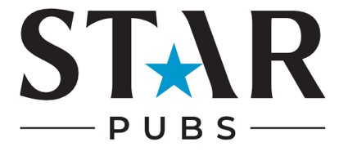

Social Media Essentials Checklist

A checklist of 5 things to ensure you have set up your account in the best way possible.
1. Perfect profile picture
Consistently use your logo, make sure it’s not cropped, make sure it stands out. Some platforms prefer circle and some square so adjust for each.
Facebook profile picture: 170 X 170 pixels
TikTok profile photo: 20 X 20 pixels (minimum)
Instagram profile picture: 320 X 320 pixels (Instagram will display this as 110x110 pixels)
2. A keyword rich bio
Include specific and relevant keywords in your bio. Keep it natural and not spammy. Add some personality.
Include a call to action - what do you want people to do? E.g. book now, download menu, visit website.
Here are some ideas of what keywords to include in your bio:
Atmosphere e.g. cozy, lively, rustic, traditional, relaxed
Offerings e.g. local brews, pub classics, craft beers, seasonal specials
Entertainment e.g. live sports, live music, beer garden, outdoor seating
Customer experience e.g. dog-friendly, family-friendly, great service, locally sourced ingredients

3. Website link
Add a web link to your profile. Use 3rd party such as LinkTree to create a mini landing page of specific places to send traffic through to, e.g. menus, latest reviews, booking forms.
LinkTree: https://linktr.ee
4. Profile design
Consider the first impressions your profile offers when people land on it. Are the last few posts totally relevant to your experience, and are you promoting all of your unique selling points?

5. Pinned content
Pin the most important content to the top of your feed. This could be a recent event, or a video which has performed particularly well.

