**Social Media Content Equipment Checklist**

**Lighting**

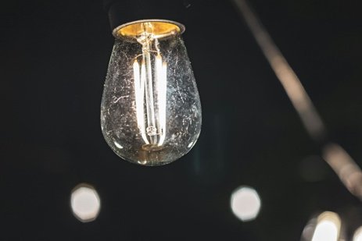High-quality lighting is crucial for social media content as it improves clarity, enhances colour and mood, and gives a professional look.

You should consider the level of natural light you have available and whether aids such as ring lights could boost your social media content.

Example Choices:

* <https://amzn.eu/d/8fIpa3J>
* https://amzn.eu/d/fcJrirD

**Tripod**

A tripod can help to stabilise your phone or camera, making it ideal for capturing steady shots and smooth pans across various angles.

Example Choices:

* <https://amzn.eu/d/iLAvHYw>
* <https://amzn.eu/d/gNFdEPP>

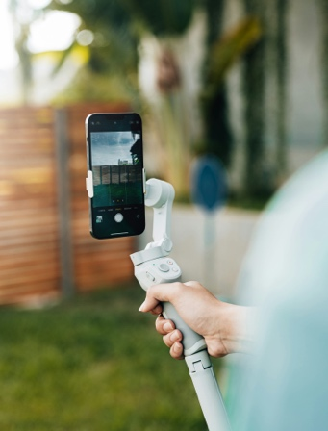

**Gimbal**

A gimbal, like a tripod, acts as a stabiliser, but it allows you to achieve stable and smooth shots while moving the camera.

Example Choices:

* <https://amzn.eu/d/4VW2wYC>
* <https://amzn.eu/d/fGugrgT>

**Lapel Microphone**

Ensuring any sound recording is high-quality is essential to creating good content. A lapel microphone can be attached to a person’s shirt and can provide clear audio to your videos.

Example Choices:

* <https://amzn.eu/d/dlo4KzS>
* <https://amzn.eu/d/6purjLd>

**Light Reflectors**

Light reflectors, sometimes referred to as light diffusers, are an affordable option for modifying lighting and can enhance the colour appearance in a photo/video.

Example Choices:

* <https://amzn.eu/d/4YfeBDb>
* <https://amzn.eu/d/cwUosnj>