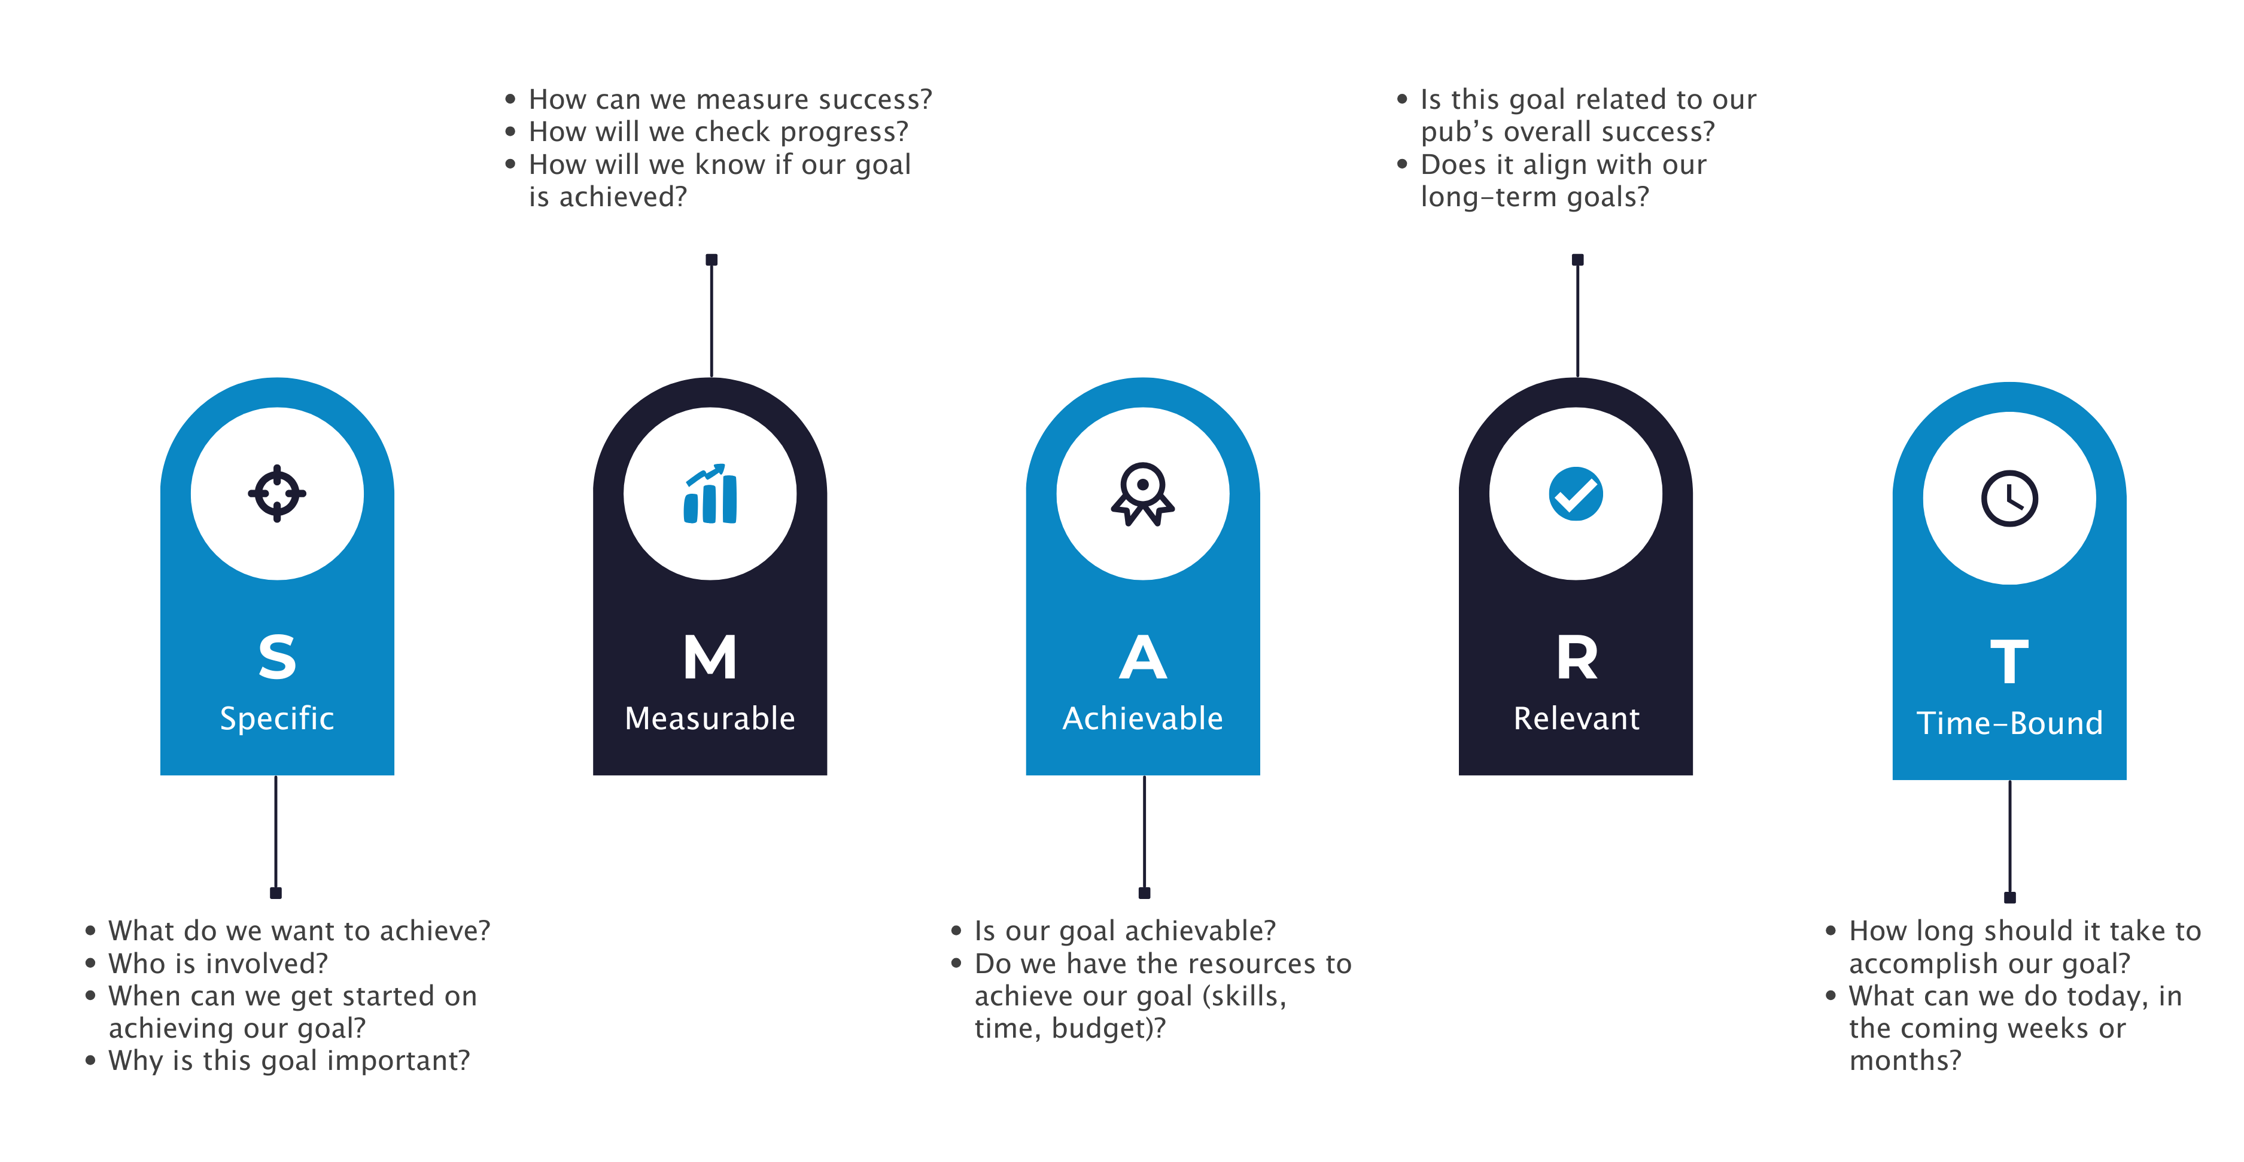**Setting SMART Goals**