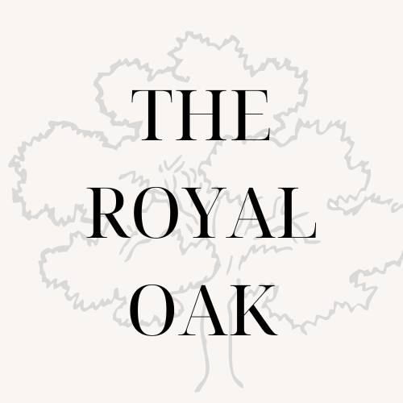

Example Social Media Strategy for a Pub
1. Purpose
What The Royal Oak Stands For:
The Royal Oak is the heart of its community, a place where people come together to celebrate, connect, and enjoy. Whether it’s a meal with family, a drink with friends, or a group celebration, the pub offers a welcoming atmosphere, excellent food, and a variety of beers, all set against the stunning backdrop of the New Forest countryside.
2. Goals
- Awareness: Increase visibility among local residents and tourists.
- Foot Traffic: Attract more visitors to the pub, especially during key events.
- Event Sales: Boost ticket sales for pub-hosted events.
- Online Reputation: Establish a positive and engaging presence on social media to encourage reviews and recommendations.

3. Audience
- Primary Audience: Locals within 20km of The Royal Oak, aged 18-65+.
- Secondary Audience: Tourists visiting the New Forest, particularly during high season.
- Key Segments:
  - Families (especially mothers booking meals or events).
  - Groups celebrating birthdays, anniversaries, and other milestones.
  - Nature lovers seeking a relaxing countryside experience.

4. Platforms
- Facebook: Ideal for reaching a local audience, promoting events, and sharing updates.
- Instagram: Perfect for showcasing food, drinks, and the beauty of the New Forest location.

5. Plan Your Content
Key Content Pillars:
- People:
  - Share stories about regular customers and their connection to the pub.

  - Feature staff members to add a personal touch.
  - Capture moments of groups enjoying their time at the pub.
- Food:
  - Highlight menu specials with appetising photos.
  - Post “behind-the-scenes” content from the kitchen.
  - Share seasonal menus or new dishes.
- Location:
  - Post scenic photos of the beer garden and the surrounding New Forest countryside.
  - Promote the pub as a great destination for tourists.
- Pub News:
  - Announce events, like quiz nights, live music, or seasonal festivals.
  - Promote special offers and competitions.
  - Celebrate milestones like anniversaries or awards.

Posting Frequency:
- 3-4 posts per week (2 on Facebook, 1-2 on Instagram).
- Ideally 1 Story per day crossposted across Facebook and Instagram (can be customer repost).
- Aim for consistency with tone: friendly, community-focused, and approachable.

6. Process
Use Meta Business Suite to:
- Plan Ahead: Schedule posts a week or two in advance.
- Engage: Respond promptly to comments and messages to maintain an active online presence.
- Track: Regularly monitor insights to see what content performs best.

7. Team
- Charlotte: Main social media manager. Creates and schedules content.
- Olly: Supports by providing photos, helping with event promotion ideas, and engaging with comments and inbox.

8. Growth Tactics
- Monthly Competitions: Encourage engagement by offering free meals, drinks, or event tickets as prizes. Example: “Tag someone you’d love to share a meal with and win a dinner for two!”
- Advertising Budget:
  - Allocate £100/month for targeted Facebook and Instagram ads (focus
  - on locals and tourists visiting the area).

  - Use £50/month for boosting posts about special events, food promotions, or seasonal offers.
  - Experiment with audience targeting to refine the reach over time.

9. Measurement
Track these key metrics weekly and review monthly:
- Reach: Number of people seeing your posts.
- Impressions: Total views on posts and ads.
- Website Traffic: Clicks on links to your website or booking system.
- Engagement: Likes, comments, shares, and saves on posts.

10. Customer Service
- Responsiveness: Aim to reply to all comments and inbox messages within 24 hours.
- Automation: Set up an automated response for messages, letting guests know:
“Thanks for reaching out to The Royal Oak! We’ve received your message and will get back to you as soon as possible. If your query is urgent, please call us at [phone number].”
- Tone: Always use a friendly and professional tone to reflect the pub’s warm and welcoming nature.
- Complaints: For serious complaints, collect the guest’s contact details and escalate the issue to Tony (manager), who will follow up personally with a phone call.
- Proactivity: Monitor and acknowledge positive reviews and comments, thanking customers for their support and encouraging them to visit again.

Implementation Tips
- Regularly update your content based on what works best.
- Make use of high-quality photos and videos to capture attention.
- Be responsive to comments and messages to build a strong sense of community.

This strategy ensures The Royal Oak maintains a positive, approachable online presence while encouraging deeper engagement with both local and tourist audiences.
(The name and details of the company used in this document are entirely fictitious and are intended for demonstration purposes only.).

