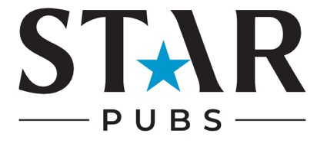

Halloween Checklist

Appearance
- Have you updated your pub’s profile picture to a Halloween themed image/version of your logo?
- Have you updated your cover image/banner to a Halloween-themed picture?
- Have you created high-quality Halloween-themed content to post across your social media channels?

Bio Content:
- How are you going to add information about your Halloween events and offers to your bio?
- Have you included a call to action? e.g. Get your tickets to our Halloween party.
- Have you included links to bookings/menus/events?

Competitions:
- Are you going to launch a Halloween competition?
- Have you decided on a worthy prize? E.g. A selection of Halloween sweets, access to your Halloween event, or a meal voucher for two?
- Are you going to promote the competition across all social media channels to boost awareness and engagement?

Ads
- What are you trying to achieve with your Halloween ad? E.g. awareness, engagement, bookings.
- Have you scheduled ads to run in the peak lead up to Halloween – usually one week before?
- Have you created Halloween-themed ads to promote your pub’s events, menus, bookings and drinks specials?
- Have you linked ads to your pub’s Halloween landing page?

Influencers
- Have you identified local influencers who align with your pub’s values?
- Have you reached out to influencers about collaborating on Halloween content?
- Have you set up arrangements for influencers to visit your pub to film/capture content?
- Are you going to reshare influencer content on the pub’s social media? How is this going to be done? E.g. repost to stories, repost to feed, collaborative post

Key dates for your pub’s diary:
Halloween

