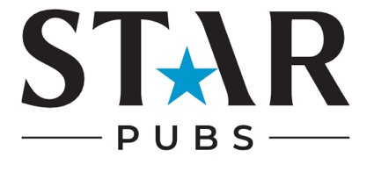

Easter Checklist

Appearance
- Have you updated your pub’s cover image/banner to an Easter-themed picture?
- Have you created high-quality Easter-themed content to post across your social media channels?

Bio Content:
- How are you going to add information about your Easter events and offers to your bio?
- Have you included a call to action? e.g. Book your Easter Sunday roast today
- Have you included links to bookings/menus/events?

Competitions:
- Are you going to launch an Easter competition?
- Have you decided on a worthy prize? E.g. A selection of Easter eggs or a voucher for a roast for two?
- Are you going to promote the competition across all social media channels to boost awareness and engagement?

Ads
- What are you trying to achieve with your Easter ad? E.g. awareness, engagement, bookings.
- Have you scheduled ads to run in the peak lead up to Easter weekend?
- Have you created Easter-themed ads to promote your pub’s events, menus, bookings and drinks specials?
- Have you linked ads to your pub’s Easter and booking landing page?

Influencers
- Have you identified local influencers who align with your pub’s values?
- Have you reached out to influencers about collaborating on Easter content?
- Have you set up arrangements for influencers to visit your pub to film/capture content?
- Are you going to reshare influencer content on the pub’s social media? How is this going to be done? E.g. repost to stories, repost to feed, collaborative post

Key dates for your pub’s diary:
Easter holidays for schools
Easter Friday
Easter Sunday
Easter Monday

