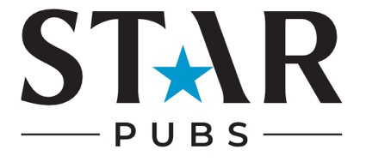

Audit Cheatsheet
1. Profile
Logo:
- Is your logo clear and high-quality?
- Is it consistent across all platforms?
Bio:
- Does your bio clearly describe what your pub is about?
- Are your opening hours, location, and contact info easy to find?
Profile Links:
- Is your website or booking link updated and functioning?
- Are you using LinkTree? Do you have too many/enough relevant and updated links?

2. Content
- Are you using high-quality images and videos that represent your pub’s atmosphere and offerings?
- Are you posting a balanced mix of content across key themes (e.g., food & drinks, events, promotions, customer stories)?
- Are you utilising trending topics or seasonal themes in your content?
- Are you using a variety of formats (photos, videos (reels), carousels, and stories)?
- Have you included user-generated content (UGC)?

3. Engagement
- Are you responding to comments on your posts?
- Are you engaging with customers who mention or tag your pub?
- Are you encouraging conversation (questions, polls, prompts)?
- Are you responding to DMs in a timely manner?
- Do you have a process for managing common inquiries (e.g., reservations, menu inquiries)?
- Are you engaging with other local businesses, influencers, or community events in your posts or comments?
- Are you actively responding to reviews on platforms like Facebook and Google?

4. Growth:
- Have you run any social media competitions - and how did they perform?
- Have you collaborated with any local influencers?
- Are you using paid advertising?

5. Measurement:
Followers & Growth:
- Is your follower count growing steadily?
- Are you attracting the right kind of followers (local, relevant demographics)?
Engagement Rates:
- How many likes, shares, comments, or saves do your posts typically receive?
- Are certain types of content (videos, promotions, behind-the-scenes) performing better than others?
Web Traffic & Conversions:
- Are you tracking how much traffic your social media is driving to your website or booking platform?
- Are you able to convert followers into customers (via offers, events, etc.)?
Metrics & Analytics:
- Are you reviewing social media analytics regularly (e.g., reach, impressions, click-through rates)?
- Are you adjusting your strategy based on the performance data?

This checklist can help ensure that your pub’s social media presence is effective, on-brand, and engaging for your audience, while also driving tangible results for your business.

